**AI BASED DESIGN OF FREQUENCY SELECTIVE SURFACE (FSS)**

**A report submitted in partial fulfillment of the requirements for**

**the award of the degree of**

**Bachelor of Technology**

**in**

**Department of Electronics and Communication Engineering**

**By**

**KAPA ADHEESHWAR REDDY (EC21B1023)**

**SADHU POORNA SAI (EC21B1043)**

**SANAPALA CHANDRA SEKHAR (EC21B1044)**



**DEPARTMENT OF**

**ELECTRONICS AND COMMUNICATION ENGINEERING NATIONAL INSTITUTE OF TECHNOLOGY PUDUCHERRY**

**KARAIKAL – 609 609**

**NOVEMBER 2024**

**BONAFIDE CERTIFICATE**

**This is to certify that the project work entitled “AI Based Design of Frequency Selective Surface (FSS)” is a bonafide record of the work done by**

**KAPA ADHEESHWAR REDDY(EC21B1023)**

**SADHU POORNA SAI (EC21B1043)**

**SANAPALA CHANDRA SEKHAR (EC21B1044)**

**in partial fulfillment of the requirements for the award of the degree of Bachelor of Technology in Electronics and Communication Engineering of the NATIONAL INSTITUTE OF TECHNOLOGY PUDUCHERRY during the year 2024 - 2025.**

**Dr. Boopathi Rani R Dr. Malaya Kumar Nath**

**Assistant Professor Head of Department**

**Project Guide**

**Project viva-voce held on 9th November 2024**

**Internal Examiner External Examiner**

**ABSTRACT**

The development of Frequency Selective Surfaces (FSS) plays a role, in enhancing electromagnetic applications such as radar systems and communication technologies while also improving EMI shielding capabilities. Traditional approaches to FSS design are typically repetitive and time intensive, with scalability. This initiative suggests utilizing AI technology to streamline the design and enhancement of FSS configurations by training machine learning models to forecast and tune the response using essential design factors. We created a network model based on transmission coefficients and frequency data, from S21 datasets obtained through simulations in order the design process faster, by accurately estimating transmission characteristics.

Our method involves utilizing a network model that has been fine tuned with the Adam optimizer and operates at an optimized learning rate with the goal of minimizing Mean Squared Error (MSE) when forecasting the S21 transmission response results. By training, on a rich dataset comprising design parameters and frequency responses data points comprehensively gathered for varying input conditions range. this model can effectively anticipate transmission behaviours under circumstances. This predictive ability speeds up the design. Prototyping phases by minimizing the need, for time consuming trial and error approaches. Furthermore the system includes a module, for optimization that automatically modifies design parameters to meet target specifications without requiring manual testing. By enhancing both prediction and optimization processes our AI driven method for FSS design provides an effective route to quickly reaching desired performance goals representing an advancement, from conventional FSS design methods.

***Keywords:*** Frequency Selective Surfaces (FSS), S21 Transmission Coefficient, Adam Optimizer, Forward Prediction Network (FPN), Improved Particle Swarm Optimization (IPSO), Mean Squared Error (MSE)

**ACKNOWLEDGEMENT**

We are grateful to thank our **Director, Dr. Makarand Madhao Ghangrekar,** for his motivation and providing us necessary infrastructure for doing the project work.

We express our sincere and heartful gratitude to our **Guide,** **Dr. Boopathi Rani R, Department of ECE** for his guidance and supervision at all levels of our project work.

We express our profound sense of gratitude to our **Head of the department, Dr. Malaya Kumar Nath** for his encouragement and whose unflagging zeal has catalysed us to strive for greater heights during the span of our course at the **National Institute of Technology Puducherry.**

We thank our beloved **Faculty and Staff members of the ECE Department** for their kind cooperation and encouragement during our project.

We thank our parents and friends who constantly supported us and helped us to complete the project.

**TABLE OF CONTENTS**

|  |  |  |
| --- | --- | --- |
| **CHAPTER NO** | **TITLE** | **PAGE NO** |
|  | ABSTRACT  ACKNOWLEDGEMENT  TABLE OF CONTENTS  LIST OF FIGURES  LIST OF ABBREVIATIONS | 3  4  5  7  8 |
| 1 | INTRODUCTION   * 1. General Introduction   2. Objectives of the thesis | 9  10 |
| 2 | LITERATURE REVIEW  2.1 Frequency Selective Surfaces (FSS) and Design Challenges  2.2 Machine Learning in Electromagnetic Design  2.3 Forward Prediction Networks (FPN) for Fast Parameter Mapping  2.4 Optimization in FSS Design: Improved Particle Swarm Optimization (IPSO)  2.5 AI-Based Design Methodologies and Comparative Efficiency  2.6 Gaps and Future Directions | 11  11  11  12  12  12 |
| 3 | PROPOSED METHODOLOGY  3.1 Overview of the Methodology  3.2 Forward Prediction Network (FPN)  3.3 Improved Particle Swarm Optimization (IPSO) Algorithm  3.4 Integration of FPN with IPSO for FSS Optimization  3.5 Simulation and Validation of Optimal Design | 13  13  15  16  17 |
| 4 | PHASE 1: DESIGNING A MICROSTRIPLINE  4.1 Introduction  4.2 Methodology  4.2.1 Design a MicroStripline  4.2.2 AI Models for S21 Prediction and Length Determination  4.3 Results and Analysis  4.4 Summary | 18  18  18  19  21  24 |
| 5 | PHASE 2: DESIGNING A FREQUENCY SELECTIVE SURFACE (FSS) OF EXISTING IMPLEMENTATION  5.1 Introduction  5.2 Methodology  5.2.1 FSS Design Overview and Parameter Specifications  5.2.2 Forward Prediction Network (FPN)  5.2.3 Improved Particle Swarm Optimization (IPSO)  5.3 Results and Analysis  5.4 Summary | 25  25  25  27  28  31  33 |
| 6 | PHASE 3: BIOCHEMICAL REACTOR  6.1 Introduction  6.2 Description  6.3 Methodology  6.3.1 FSS Design Overview and Parameter Specifications  6.3.2 Forward Prediction Network (FPN)  6.3.3 Improved Particle Swarm Optimization (IPSO)  6.4 Results and Analysis  6.5 Summary | 34  34  36  36  36  37  39  40 |
| 7 | CONCLUSION  7.1 Summary  7.2 Conclusion  7.3 Directions for future work | 41  42  43 |
|  | REFERENCES | 44 |

**LIST OF FIGURES**

|  |  |  |
| --- | --- | --- |
| **Figure No.** | **Title** | **Page No** |
| 3.1 | Flow chart of the proposed method | 13 |
| 4.1 | Block Diagram of Model 1 – S21 Prediction | 19 |
| 4.2 | Block Diagram of Model 2 – Length Prediction | 20 |
| 4.3 | Output of Model 1 – S21 Prediction | 22 |
| 4.4 | Visualization of Predicted S21 vs Frequency (GHz) | 22 |
| 4.5 | Output of Model 2 – Length Prediction | 23 |
| 4.6 | Heat Map Visualization of S21 vs Frequency (GHz) vs Length (mm) | 24 |
| 5.1 | Simulation Image of FSS in HFSS Software with Square Strip | 26 |
| 5.2 | Flow chart of parameters optimization | 28 |
| 5.3 | Output of Model (Optimal Parameters) | 31 |
| 5.4 | Visualization of Frequency (GHz) vs S21 of Predicted Values (dB) | 32 |
| 6.1 | Simulation Image of FSS in HFSS Software of Decagon Strip | 35 |
| 6.2 | Output of Model (Optimal Parameters) | 39 |
| 6.3 | Visualization of Frequency (GHz) vs S21 of Predicted Values (dB) | 40 |

**LIST OF ABBREVIATIONS**

FSS – Frequency Selective Surface

FPN – Forward Prediction Network

IPSO – Improved Particle Swarm Optimization

MSE – Mean Squared Error

EMI – Electromagnetic Interference

ReLU – Rectified Linear Unit

PSO – Particle Swarm Optimization

HFSS – High Frequency Structure Simulator

**CHAPTER 1**

**INTRODUCTION**

* 1. **GENERAL INTRODUCTION**

Frequency Selective Surfaces (FSS) are critical components in a wide range of electromagnetic applications, including radar, communication systems, and electromagnetic interference (EMI) shielding. Traditional methods of designing FSS structures typically involve iterative simulation and testing, which are both time-consuming and resource-intensive. With the increasing complexity of electromagnetic environments, there is a growing need for faster and more efficient design techniques that can reduce the time spent on prototyping and optimization while maintaining performance accuracy.

This project proposes an AI-based approach to streamline the design and optimization of FSS. By utilizing machine learning, particularly neural networks, the project aims to predict the frequency response of FSS structures based on design parameters, significantly improving the speed and accuracy of the design process. The proposed model is trained on a dataset of S21 transmission coefficients and frequency data obtained from parametric simulations, allowing for precise prediction of transmission characteristics. Additionally, an optimization algorithm is integrated to automatically adjust design parameters, ensuring the desired performance goals are met. This AI-driven approach offers a scalable and efficient alternative to traditional FSS design methods, opening new possibilities for rapid, high-performance electromagnetic design.

* 1. **Objectives of thesis**
* Develop an **AI-based methodology** for the efficient design and optimization of Frequency Selective Surfaces (FSS) for applications such as radomes, EMI shielding, and communication systems.
* Implement a **neural network-based Forward Prediction Network (FPN)** to predict the transmission characteristics (S21 values) of FSS structures, reducing reliance on time-intensive full-wave simulations.
* Integrate the FPN with an **Improved Particle Swarm Optimization (IPSO) algorithm** to automatically adjust structural parameters for meeting specified frequency response requirements.
* Achieve significant **reductions in computational time and resource requirements** for FSS design, enhancing prototyping and design processes.
* Ensure **high prediction accuracy** and efficient optimization for complex FSS topologies, demonstrating the feasibility of the AI-based approach as a scalable alternative to traditional methods.

**CHAPTER 2**

**LITERATURE REVIEW**

**2.1. Frequency Selective Surfaces (FSS) and Design Challenges**

FSS structures serve as spatial filters and are widely used in applications such as antenna radar domes, EMI shielding, and signal filtering. The paper notes that traditional design methods rely heavily on iterative full-wave simulations or equivalent circuit models, which, while versatile and accurate, are computationally expensive and time-consuming for complex topologies.

The dependence of FSS performance on multiple factors, such as structural topology, incident angle, and polarization, adds further complexity, highlighting the need for rapid and accurate design methods to meet specific frequency requirements.

**2.2. Machine Learning in Electromagnetic Design**

The application of deep learning in electromagnetic design has gained traction for its ability to efficiently map input design parameters to output characteristics, bypassing time-intensive simulations. Studies have shown that neural networks can predict electromagnetic responses, such as S-parameters, with significant accuracy when trained on large datasets​.

In FSS and metasurface design, fully connected networks, convolutional neural networks (CNNs), and recurrent neural networks (RNNs) have been applied to capture the nonlinear relationships between structural parameters and transmission properties. This AI-driven approach can enhance efficiency, although challenges remain in achieving high accuracy for inverse design tasks.

**2.3. Forward Prediction Networks (FPN) for Fast Parameter Mapping**

The paper implements a Forward Prediction Network (FPN) based on a fully connected neural network to predict the S21 transmission coefficient of FSS structures. This approach replaces traditional full-wave simulations for faster and computationally efficient parameter mapping, especially useful when real-time prototyping is essential.

The FPN model, trained on a large dataset, demonstrates high accuracy in predicting S21 values over a range of frequencies, which helps streamline the design process by providing immediate feedback on parameter changes.

**2.4. Optimization in FSS Design: Improved Particle Swarm Optimization (IPSO)**

Optimization algorithms like Particle Swarm Optimization (PSO) and Genetic Algorithms (GA) have been widely used to fine-tune FSS structural parameters. However, traditional PSO can struggle with slow convergence and local optima issues in complex design spaces.

To address these challenges, the paper integrates an Improved Particle Swarm Optimization (IPSO) with adaptive inertia weight and dynamically adjusted learning coefficients. This enhancement accelerates convergence while improving global search capability, effectively balancing exploration and exploitation during parameter tuning.

**2.5. AI-Based Design Methodologies and Comparative Efficiency**

Combining FPN with IPSO enables a rapid and accurate FSS design approach. The paper reports that this integrated method achieves a 99% improvement in optimization efficiency compared to traditional full-wave simulation-based methods, with high design accuracy. The transmission coefficient errors remain within 1 dB of target values, and the deviation in centre frequency and bandwidth is minimal.

Compared to other deep learning approaches, this combination of prediction and optimization improves both speed and reliability, positioning it as a highly efficient method for FSS design. The study exemplifies how AI-based methods can achieve substantial performance gains over conventional optimization techniques.

**2.6. Gaps and Future Directions**

Despite the advancements, there is still a need to explore AI-based methods that improve accuracy in inverse design tasks for FSS and metasurfaces, where the required structural parameters are derived from target frequency responses. Additionally, further development of robust, generalized FPN architectures that can adapt to different FSS topologies without re-training would greatly benefit real-world applications.

**CHAPTER 3**

**Proposed Methodology**

**3.1. Overview of the Methodology**

The methodology leverages a dual-component system—consisting of a Forward Prediction Network (FPN) and an Improved Particle Swarm Optimization (IPSO) algorithm—to optimize the design parameters of a Frequency Selective Surface (FSS) structure. By combining the predictive capability of FPN with the optimization strength of IPSO, this method aims to achieve a design that meets specified frequency response requirements with significantly reduced computational time and effort compared to traditional iterative simulation approaches.

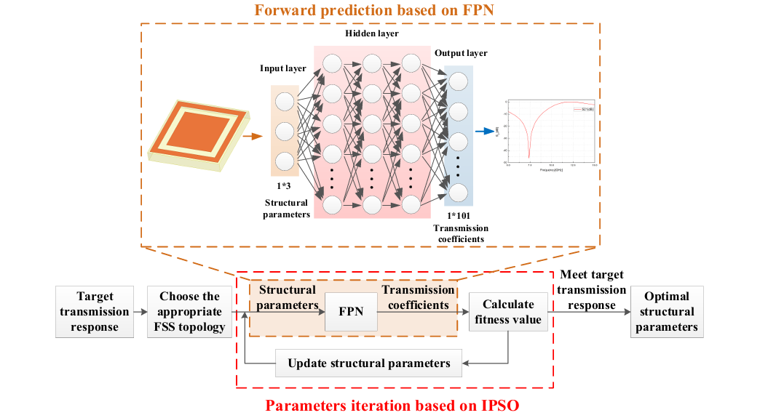

Fig (3.1) Flow chart of the proposed method

**3.2. Forward Prediction Network (FPN)**

* Purpose and Role of FPN:
  + In traditional FSS design, every design iteration requires full-wave simulation, which is computationally intensive. The FPN replaces this costly simulation by serving as a predictive model that maps structural parameters to the resulting transmission coefficient curve. This shift allows the optimization process to evaluate designs rapidly without direct simulation.
* Data Acquisition:
  + To train the FPN, a substantial dataset representing diverse FSS structures and their frequency responses is generated. Using electromagnetic simulation software (such as HFSS), each FSS structure is simulated to produce transmission data, covering a range of frequencies.
  + The FSS structure is parameterized, with some dimensions and material properties fixed to maintain structural consistency, while other critical parameters are varied within defined ranges. These adjustable parameters (like loop and patch dimensions) affect the FSS response and thus form the basis for optimization.
  + Thousands of data samples are generated, each consisting of an input vector of structural parameters and an output transmission coefficient curve. The frequency response data captures the curve across a set frequency range, with each data point representing the magnitude of the transmission coefficient at a specific frequency.
* Network Architecture and Configuration:
  + A fully connected feedforward neural network is selected as the architecture for the FPN. This configuration is effective for approximating continuous mappings, making it suitable for predicting transmission coefficients.
  + The input layer receives the set of adjustable FSS parameters. Multiple hidden layers with progressively more neurons capture complex relationships between parameters and transmission properties, and an output layer provides the transmission coefficient values across the frequency range.
  + Hyperparameters, such as the choice of LeakyReLU for activation, Mean Squared Error (MSE) as the loss function, and the Adam optimizer, are chosen to improve training efficiency and prediction accuracy. The network is trained over multiple iterations until convergence, where a low final loss value confirms the network's predictive accuracy.
* Training and Validation:
  + The dataset is split into training, validation, and testing sets to assess model performance and prevent overfitting. After training, the network’s predictions are compared to simulated values from the electromagnetic software.
  + Validation results demonstrate that the trained FPN closely approximates the simulated transmission coefficient curve. This accuracy enables the FPN to be a reliable surrogate for direct simulation, accelerating the optimization process without sacrificing fidelity.

**3.3. Improved Particle Swarm Optimization (IPSO) Algorithm**

* Objective of IPSO in the FSS Design Process:
  + IPSO is responsible for optimizing the structural parameters of the FSS to meet a predefined transmission response target. In the optimization process, IPSO iteratively adjusts parameters to minimize the difference between the predicted transmission response and the target response.
* Basic PSO Mechanism:
  + In PSO, a set of particles, each representing a potential solution, are initialized with random values for the FSS structural parameters. Each particle has a position vector (the current set of parameters) and a velocity vector (rate of change for each parameter).
  + Particles move through the solution space by updating their position and velocity iteratively, based on their individual best-known position and the globally best-known position among all particles. This enables particles to converge toward optimal regions of the solution space.
* Enhancements in IPSO:
  + Nonlinear Adaptive Inertia Weight (ω):
    - The inertia weight, ω, controls the balance between global and local search. In IPSO, ω adjusts dynamically based on the distribution of particle fitness values. Initially, ω is larger, encouraging broader exploration of the solution space to avoid premature convergence. As particles get closer to the optimal solution, ω decreases to enhance local refinement.
  + Dynamic Learning Coefficients (c1 and c2):
    - Learning coefficients control the influence of a particle’s own past experiences (self-cognition) and the experiences of neighboring particles (social cognition). IPSO uses a fixed c1 to ensure consistent self-exploration but gradually reduces c2, promoting global convergence and preventing particles from getting stuck in local optima.
  + These enhancements improve the efficiency and reliability of the optimization process, allowing IPSO to find high-quality solutions faster than standard PSO.

**3.4. Integration of FPN with IPSO for FSS Optimization**

* Initialization:
  + At the start, IPSO initializes each particle with a set of structural parameters for the FSS. Each particle’s fitness is then evaluated by feeding these parameters into the FPN, which outputs the predicted transmission coefficient curve.
* Fitness Evaluation and Objective Function:
  + The fitness function quantifies the closeness of a particle’s transmission coefficient curve to the target response. The objective function is defined based on specific target conditions for transmission coefficient levels at designated frequency bands, with penalties applied for deviations.
  + For instance, the fitness function might require the transmission coefficient to be below a certain threshold in one frequency band and above it in another. Particles are evaluated against these criteria, and deviations are penalized, guiding particles towards parameter sets that best meet the design goals.
* Iterative Optimization Process:
  + Particles update their positions and velocities based on their current fitness and the global best-known solution. FPN is used in each iteration to predict transmission coefficients, eliminating the need for time-consuming simulations.
  + The optimization continues until a convergence criterion is met, such as reaching the maximum number of iterations or achieving a fitness value within an acceptable threshold. IPSO’s adaptive parameters enable rapid convergence, focusing search efforts on promising areas of the solution space as the optimization proceeds.
* Optimal Parameter Selection:
  + Upon convergence, the particle with the best fitness score represents the optimal FSS structural parameters. IPSO’s performance can be benchmarked against basic PSO, typically showing faster convergence and superior accuracy due to the enhancements introduced in the inertia weight and learning coefficients.

**3.5. Simulation and Validation of Optimal Design**

* Simulation of Optimized Structure:
  + The optimized FSS parameters are then used to construct the FSS model in electromagnetic simulation software for verification. This simulation assesses the accuracy of the FPN-IPSO predictions by comparing them to the actual transmission coefficient curve.
* Validation Against Target Specifications:
  + The optimized design is evaluated to ensure it meets the target frequency requirements with minimal deviation. Key points across the frequency range are analyzed to verify that transmission coefficients align closely with the target values, with any deviations kept within acceptable error margins.
* Comparison with Traditional Methods:
  + By comparing the time taken for the FPN-IPSO process to traditional full-wave simulation-based optimization, the method demonstrates a substantial efficiency improvement, often reducing design time by over 90%. This efficiency gain underscores the method’s suitability for real-world applications requiring rapid and accurate FSS designs.

**CHAPTER 4**

**PHASE 1: DESIGNING A MICRO STRIPLINE**

**4.1 Introduction**

A Microstripline is a widely used planar transmission line that supports quasi-TEM (transverse electromagnetic) wave propagation, making it suitable for high-frequency applications such as antennas, filters, and matching networks in RF and microwave engineering. Comprising a conducting strip separated from a ground plane by a dielectric substrate, the microstripline is favored for its ease of fabrication, compatibility with printed circuit board (PCB) technology, and adaptability in various frequency-selective applications. The microstripline’s key characteristics—such as impedance, attenuation, and transmission properties—are influenced by parameters like substrate material, conductor width, length, and frequency of operation.

In Frequency Selective Surfaces (FSS), microstriplines can be crucial, serving as fundamental elements for transmitting or filtering specific frequency bands. The S-parameters, particularly S21 (the transmission coefficient), are critical metrics in evaluating these characteristics, reflecting how much of an incident signal is transmitted through the microstripline without attenuation.

Here, the microstripline design is optimized using artificial intelligence. Neural network models are employed to predict the S21 values based on frequency inputs, allowing for rapid characterization of transmission performance. Furthermore, an additional model estimates the microstripline length required for specific S21 values and frequencies, helping designers refine physical dimensions in the FSS application. This AI-driven approach offers a time-efficient and accurate method to model and optimize the microstripline's transmission characteristics, forming a foundational step in the overall AI-Based Design for FSS.

**4.2 Methodology**

**4.2.1 Design of the Microstripline**

The microstripline was designed as a foundational element for FSS analysis. Its physical and electrical characteristics depend on parameters like width, length, substrate type, and operating frequency. In this design:

* Substrate Type: A suitable dielectric substrate is selected based on the intended application’s frequency range.
* Width and Length Calculations: Initial width and length were computed to ensure impedance matching, maintaining the desired transmission characteristics over a defined frequency range.

**4.2.2 AI Models for S21 Prediction and Length Determination**

Two distinct machine learning models were developed to streamline the microstripline design and prediction process:

* **Model 1 - S21 Prediction**:
  + **Objective**: The primary objective of this model is to predict the transmission coefficient (S21) across a range of frequencies. The transmission coefficient is critical in assessing how electromagnetic waves pass through the microstripline, making this model central to the design process.
  + **Input**: The input to the model is the frequency (in GHz). The frequency values are extracted from a dataset that contains historical S21 data.
  + **Output**: The model outputs the S21 value (in dB), which represents the transmission coefficient at a given frequency.

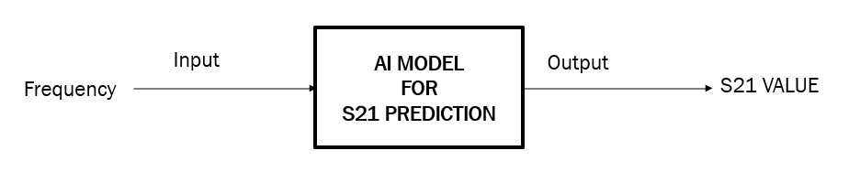

Fig (4.1) Block Diagram of Model 1 – S21 Prediction

* + **Model Architecture**: The S21 prediction model utilizes a **Linear Regression** algorithm. The model is trained using historical data containing frequency and corresponding S21 values. This model uses a simple linear regression approach to fit a line that best predicts the S21 value for a given frequency. The dataset is split into training and testing sets, and the model's accuracy is evaluated using metrics such as Mean Squared Error (MSE) and R² Score. The model's performance is visualized through a plot comparing actual versus predicted S21 values.
  + **Evaluation**: The model was tested on unseen data, demonstrating its ability to predict S21 values with reasonable accuracy. The model’s Mean Squared Error (MSE) and R² Score indicate a high level of accuracy in predicting S21 values, which are essential for further analysis of the microstripline's transmission properties.
* **Model 2 - Length Prediction**:
  + **Objective**: The second model aims to predict the physical length of the microstripline based on both frequency and the S21 value. This is important for optimizing the design of microstripline elements to meet specific transmission characteristics.
  + **Input**: The input to this model consists of two parameters: the frequency (in GHz) and the corresponding S21 value (in dB) obtained from the first model.
  + **Output**: The model outputs the predicted microstripline length (in mm).

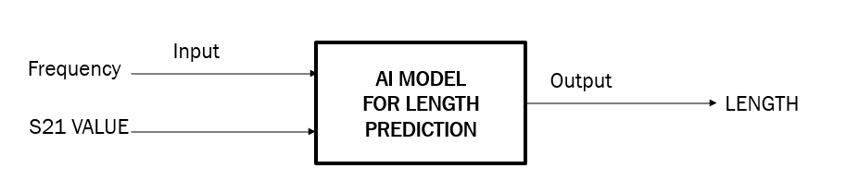

Fig (4.2) Block Diagram of Model 2 – Length Prediction

* + **Model Architecture**: For the length prediction, a more sophisticated approach is employed. This model uses a **Ridge Regression** technique, incorporated into a pipeline that includes **Polynomial Features** to model nonlinear relationships between the input parameters (frequency and S21). A **GridSearchCV** approach is utilized to fine-tune hyperparameters, such as the degree of the polynomial and the regularization strength (alpha) for Ridge regression. This method ensures that the model can capture complex patterns in the data and provide accurate length predictions. The model is trained on a dataset where length, frequency, and S21 values are correlated.
  + **Evaluation**: The model’s performance is evaluated using metrics such as **Mean Squared Error (MSE)** and **R² Score**. The model demonstrated a strong ability to predict microstripline lengths with minimal error. Additionally, the results were visualized through a heatmap comparing predicted and actual lengths, showcasing the model’s effectiveness.
  + **User Interaction**: The model is further enhanced with a user interaction feature, where users can input specific frequency and S21 values, and the model will predict the corresponding microstripline length. This real-time prediction tool adds a level of interactivity and flexibility, making it suitable for dynamic design adjustments during the FSS development process.
  + **Optimization**: The model also integrates with **Particle Swarm Optimization (PSO)** to further optimize the predicted length values by iterating through possible configurations of the parameters to minimize prediction error.

**4.3 Results and Analysis**

The performance of the AI-based models was evaluated based on the predictive accuracy and their ability to generate relevant design parameters for the microstripline. Below are the key findings from the evaluation of both models:

**Model 1 - S21 Prediction Accuracy**

The S21 prediction model, trained using historical data, successfully predicted the transmission coefficient for various frequencies. The results were compared against actual S21 measurements, and the accuracy was assessed using the following metrics:

* Mean Squared Error (MSE): The model demonstrated a low error in predicting the S21 values.
* R² Score: The model achieved a high R² score, indicating a good fit between the predicted and actual S21 values.

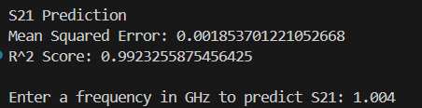

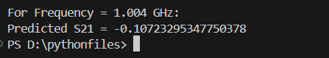

Fig (4.3) Output of Model 1 – S21 Prediction

**Visualization:** The predicted S21 values were plotted against the actual S21 values for the test dataset. The plot shows how closely the model's predictions align with the observed values. The results are visually represented in the output image showing a comparison between the actual and predicted S21 values, helping to confirm the model's effectiveness in predicting the transmission coefficient.

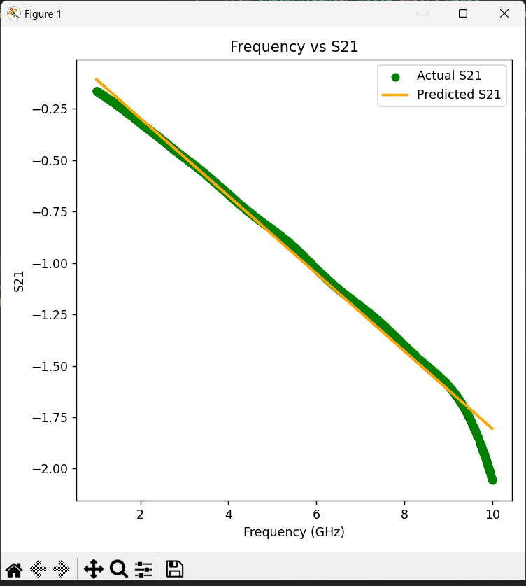

Fig (4.4) Visualization of Predicted S21 vs Frequency (GHz)

**Model 2 - Length Prediction Accuracy**

For the second model, which predicts the microstripline length based on both frequency and S21 values, the results demonstrated:

* Mean Squared Error (MSE): The length prediction model also showed a strong performance, with a low MSE, indicating minimal deviation between predicted and actual lengths.
* R² Score: The model achieved a high R² score, signifying a good correlation between predicted and actual lengths.

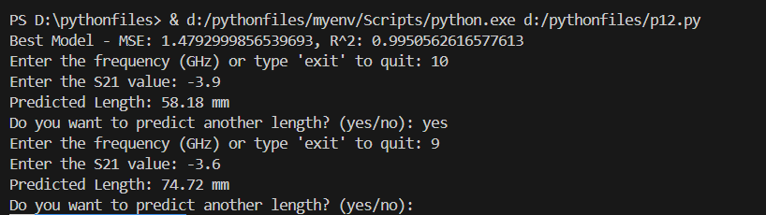

Fig (4.5) Output of Model 2 – Length Prediction

MSE:65.216489 R^2:0.798421 (2A)

Best Model - MSE: 1.4792999856539693(2B)

R^2: 0.9950562616577613(2B)

Enter the frequency (GHz) or type 'exit' to quit: 10

Enter the S21 value: -3.9

Predicted Length: 58.18 mm

Do you want to predict another length? (yes/no): yes

Enter the frequency (GHz) or type 'exit' to quit: 9

Enter the S21 value: -3.6

Predicted Length: 74.72 mm

**Visualization:** The predicted lengths were plotted against the actual lengths for the test dataset. Additionally, a 3D plot of the relationship between Frequency, S21, and Length was generated. This visualization demonstrates how the length varies as a function of both frequency and the S21 transmission coefficient, providing insights into the microstripline's design characteristics. This helps visualize how changes in S21 and frequency influence the physical length of the microstripline.

**Heatmap Comparison:** A heatmap was generated to compare predicted and actual lengths across a grid of frequency and S21 values. This allows for a comprehensive visual understanding of the model's predictive performance and its ability to approximate the microstripline length over a wide range of operating conditions.

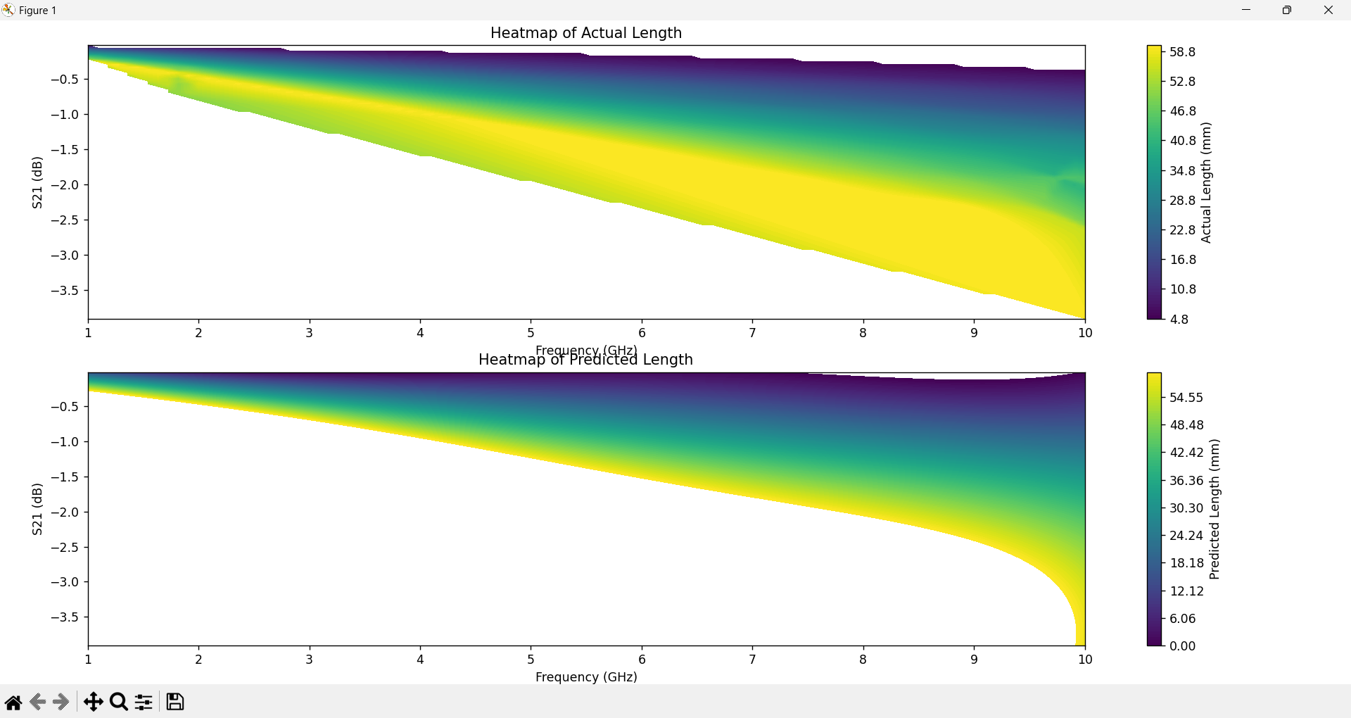

Fig (4.6) Heat Map Visualization of S21 vs Frequency (GHz) vs Length (mm)

**4.4 Summary**

The microstripline design and AI-driven modelling approach underscore the value of integrating machine learning in electromagnetic design. By predicting S21 values and determining optimal microstripline lengths, this method offers a powerful tool for FSS design. The success of these models highlights the potential of AI to accelerate and refine the design of transmission elements, providing a foundation for more complex FSS structures in future work.

**CHAPTER 5**

**PHASE 2: DESIGNING A FREQUENCY SELECTIVE SURFACE (FSS) OF EXISTING IMPLEMENTATION**

**5.1 Introduction**

Frequency Selective Surfaces (FSS) are periodic structures that selectively filter electromagnetic waves, commonly used in RF and microwave applications such as antennas, radomes, and electromagnetic shielding. Designing an FSS with specific transmission characteristics is essential in these fields, but the process can be computationally demanding due to the need for extensive full-wave simulations.

This chapter introduces a novel AI-based approach to expedite the FSS design process by combining a Forward Prediction Network (FPN) with an Improved Particle Swarm Optimization (IPSO) algorithm. The FPN rapidly predicts transmission coefficients (S21), replacing traditional simulations, while IPSO fine-tunes the structural parameters for optimal frequency response. This combined model provides a highly efficient, accurate alternative to conventional methods.

**5.2 Methodology**

**5.2.1 FSS Design Overview and Parameter Specifications**

The FSS design from the paper is a band-stop structure that filters specific frequency ranges while allowing other frequencies to pass. It consists of a periodic unit cell featuring a square loop with three key dimensions: the inner side length (2L1), the outer side length (2L2), and the side length of an internal square patch (2L3). The following parameters are specified for this design:

* Unit Cell Size (P): 8 mm
* Dielectric Layer Thickness (h): 1 mm
* Relative Permittivity (εr): 2.65

The variable parameters are [L1], [L2], and [L3], which determine the resonance and transmission characteristics of the FSS. These parameters are optimized to achieve target S21 values at specific frequencies. In this design, [L1], [L2], and [L3] are varied within the ranges:

* Inner Side Length (2L1): 5.6 mm to 6.4 mm
* Outer Side Length (2L2): 6.8 mm to 7.6 mm
* Internal Patch Side Length (2L3): 4.0 mm to 5.0 mm

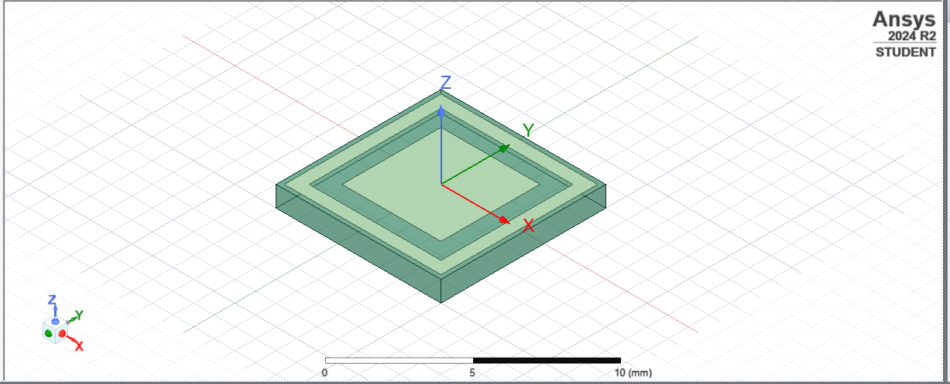



Copper



Substrate

Fig (5.1) Simulation Image of FSS in HFSS Software with Square Strip

The primary objective of the FSS design is to meet transmission coefficient (S21) requirements within two specific frequency ranges:

* S21 < -15 dB for 9-10 GHz (band-stop behaviour)
* S21 > -0.5 dB for 12-14 GHz (high transmission)

These target specifications ensure that the FSS can effectively filter certain frequencies while allowing others to pass, which is crucial for applications requiring controlled wave propagation.

**5.2.2 Forward Prediction Network (FPN)**

The Forward Prediction Network (FPN) is a fully connected neural network used to predict the S21 transmission coefficient of an FSS design. Instead of relying on traditional full-wave simulations, which are computationally intensive, the FPN approximates the relationship between the structural parameters ([L1], [L2], and [L3]) and S21 values over a specified frequency range. This substitution significantly reduces the time required for S21 prediction and enhances the efficiency of the design process.

FPN Architecture and Configuration:

* Input Layer: The FPN takes three inputs—L1, L2, and L3, the structural parameters of the FSS design.
* Hidden Layers: The network consists of multiple dense layers, each with a specific number of neurons to capture complex relationships in the data. For this FPN, hidden layers contain 50, 100, and 200 neurons, with each layer activated by a LeakyReLU function to introduce nonlinearity while mitigating the vanishing gradient problem.
* Output Layer: The output layer consists of 101 neurons, corresponding to S21 values across 101 frequency points within the specified frequency range.

Training Configuration:

* Loss Function: Mean Squared Error (MSE) is used to evaluate the model's prediction accuracy.
* Optimizer: The Adam optimizer is used with a learning rate of 1e-4 for efficient convergence.
* Batch Size and Epochs: The model is trained with a batch size of 32 for 200 epochs, ensuring both efficiency and model stability.

Data Preparation: The FPN is trained on a dataset where S21 values are provided in linear form (as opposed to dB), which smooths the data and facilitates better model convergence. After training, the FPN is tested on a separate dataset to evaluate its generalization capability. Visualizations of predicted versus actual S21 values confirm the accuracy of the model, demonstrating the FPN's ability to predict transmission coefficients with minimal error.

**5.2.3** **Improved Particle Swarm Optimization (IPSO)**

The Improved Particle Swarm Optimization (IPSO) algorithm is employed to optimize the structural parameters ([L1], [L2], and [L3]) based on the predictions generated by the FPN. IPSO enhances the conventional Particle Swarm Optimization (PSO) method by introducing adaptive inertia weights and dynamic learning coefficients, which improve both the convergence speed and accuracy in finding optimal solutions.

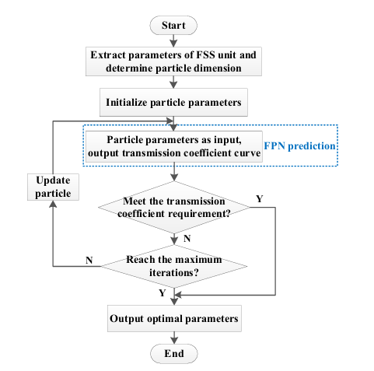

Fig (5.2) Flow chart of parameters optimization

Key Components of IPSO: Each particle in the IPSO algorithm represents a candidate solution for the FSS parameters ([L1], [L2], [L3]). The goal is to find the particle configuration that minimizes the fitness function, indicating the best match to the desired S21 target values.

1. Particles and Fitness Evaluation:
   * Each particle has a position Xi=[L1,L2,L3] and a velocity Vi=[vi1,vi2,vi3].
   * Fitness is calculated based on the S21 values predicted by the FPN for each particle’s configuration. The fitness function, F, is defined as Eq. 5.1

$F= {\left(S_{21}^{9GHz}+15\right)}^{2}+{\left(S_{21}^{10GHz}+15\right)}^{2}+{\left(S_{21}^{12GHz}+15\right)}^{2}+{\left(S_{21}^{14GHz}+15\right)}^{2}$ (5.1)

1. where S21 represents the predicted transmission coefficient at frequency f. This fitness function penalizes deviations from the target values, guiding the optimization towards ideal configurations that meet the S21 specifications for key frequencies.
2. Adaptive Inertia Weight (ω):
   * The inertia weight ω controls the balance between global exploration and local exploitation. A larger ω promotes a wider search of the solution space, while a smaller ω focuses on refining local solutions.
   * The adaptive inertia weight is calculated using the Eq. 5.2
$$ω_{i}^{d}=\left\{\begin{matrix}ω_{min}++\left(ω_{max}-ω_{min}\right)\frac{f(x_{i}^{d})-f_{min}^{d}}{f_{average}^{d}-f_{min}^{d}}, f(x_{i}^{d})≤f_{average}^{d} \\ ω_{max}, f(x_{i}^{d})>f_{average}^{d}\end{matrix}\right. (5.2)$$

3. where:
   * fi is the fitness value of particle i.
   * fmin is the minimum fitness value among all particles.
   * favg​ is the average fitness value.
   * ωmax ​ and ωmin are the maximum and minimum inertia weights, respectively,
   * fgbest​ is the global best fitness.

The adaptive ω accelerates convergence by decreasing as particles approach the global best solution, improving both speed and accuracy.

1. Dynamic Learning Coefficient (C2):
   * The social learning coefficient C2 is reduced over iterations to avoid premature convergence. A high C2 at the start enhances global search, while a lower C2 towards the end focuses on local exploitation.
   * The dynamic adjustment of C2 follows this Eq. 5.3:

$C_{2}= C_{2end}+\left(C_{2start}-C_{2end}\right)*e^{\left(\frac{w_{c}*t}{max⁡_iter}\right)}$ (5.3)

1. where:
   * C2start and C2end​ are the initial and final values of C2,
   * wc is a proportional coefficient controlling the decay rate of C2,
   * t is the current iteration, and max_iter is the maximum number of iterations.
2. Velocity and Position Update:
   * Each particle’s velocity and position are updated based on its current position, personal best position (pbest), and the global best position (gbest). The update equations are Eq. 5.4 and Eq. 5.5:

Velocity Update:

$V_{ij}\left(t+1\right)=ωV_{ij}\left(t\right)+C_{1}.{rand}_{1}.\left(p_{ij}-X_{ij}\right)+C_{2}.{rand}_{2}.(g_{j}-X_{ij})$ (5.4)

where:

* + - Vij(t+1) is the updated velocity of the i-th particle in the j-th dimension,
    - ω is the adaptive inertia weight,
    - C1 and C2 are learning factors for personal and social learning, respectively,
    - rand1​ and rand2 are random numbers uniformly distributed between 0 and 1,
    - pij is the personal best position of particle i,
    - gj is the global best position among all particles.

Position Update:

$X_{ij}\left(t+1\right)=X_{ij}\left(t\right)+V_{ij}(t+1)$ (5.5)

This update ensures that particles move toward their optimal positions over time, refining FSS structural parameters ([L1], [L2], and [L3]) to meet target S21 values.

1. Convergence:
   * The optimization process continues until a stopping criterion is met, either when the fitness reaches a predefined threshold or the maximum number of iterations is reached. Upon convergence, the best particle configuration represents the optimal structural parameters for the FSS design.

**5.3 Results and Analysis**

FPN-IPSO Model Performance

The combined FPN-IPSO model was evaluated based on its ability to accurately predict S21 and optimize FSS parameters.

* S21 Prediction: The FPN achieved low MSE and high R² scores, indicating strong accuracy in S21 predictions across the frequency range. Tests confirmed that the FPN predictions closely matched simulated S21 values, verifying its effectiveness in replacing full-wave simulations.

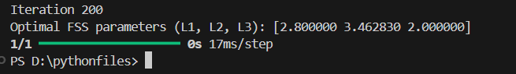

Fig (5.3) Output of Model (Optimal Parameters)

Output:

**S21 Prediction Results**

Final Training Loss: 14.633203506469727

Final Validation Loss: 14.026500701904297

**Optimal FSS parameters**

(L1, L2, L3): [2.800000 3.462830 2.000000]

Visualization: A plot comparing predicted versus actual S21 values validated the FPN’s accuracy.

* Structural Parameter Optimization: The IPSO algorithm successfully optimized [L1], [L2], and [L3] to meet the target S21 values at key frequencies (9 GHz, 10 GHz, 12 GHz, and 14 GHz). The optimization achieved:
  + S21 < -15 dB for 9-10 GHz
  + S21 > -0.5 dB for 12-14 GHz

Optimization Metrics: IPSO obtained a low MSE and high R² score, confirming accurate predictions of optimal parameters to meet the target S21 specifications.

Visualization: Predicted versus target S21 values were compared at key frequencies, illustrating IPSO's effectiveness. Additionally, a heatmap displayed the relationship between frequency, S21, and optimized FSS parameters.

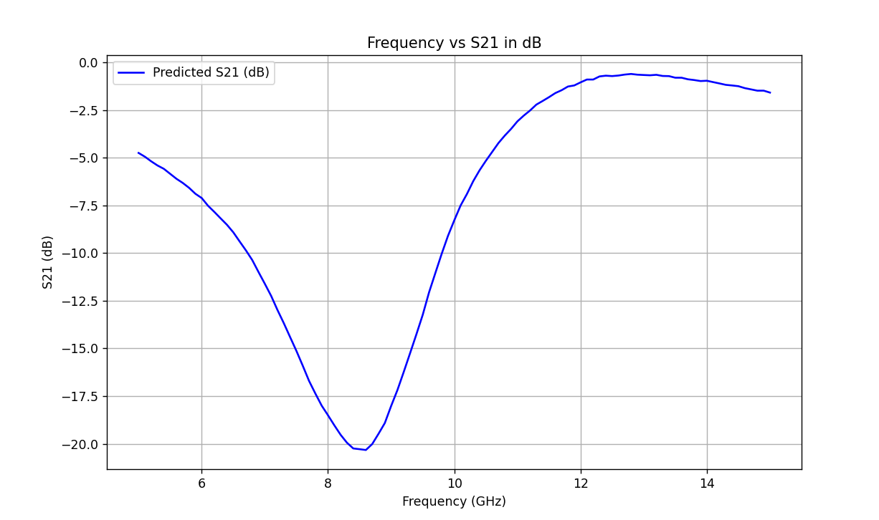

Fig (5.4) Visualization of Frequency (GHz) vs S21 of Predicted Values (dB)

**5.4 Summary**

This AI-based FSS design method combines FPN and IPSO to achieve rapid, efficient, and accurate design outcomes. By replacing traditional simulations with the FPN and using IPSO for parameter optimization, this approach improves efficiency, reducing design time by over 99% compared to conventional methods. This AI-driven methodology provides a foundation for the rapid and accurate design of FSS structures, with potential applications in more complex electromagnetic devices and systems.

**CHAPTER 6**

**PHASE 3: DESIGNING A FREQUENCY SELECTIVE SURFACE (FSS)**

**6.1 Introduction**

Frequency Selective Surfaces (FSS) are essential in RF and microwave applications, serving as spatial filters that control electromagnetic wave propagation. They are widely used in antennas, radomes, and electromagnetic shielding structures, where specific frequency selectivity is required. However, designing an FSS to meet particular transmission characteristics is computationally intensive and typically requires full-wave simulations.

This chapter introduces an AI-driven approach to streamline the FSS design process, combining a Forward Prediction Network (FPN) with an Improved Particle Swarm Optimization (IPSO) algorithm. The FPN model rapidly predicts transmission coefficients (S21), eliminating the need for costly simulations, while IPSO optimizes the FSS parameters ([s], [w], and [w2]) to achieve specific frequency responses. This combined model offers a fast, efficient alternative to traditional methods, delivering accurate predictions and optimized designs.

**6.2 Description**

Layered Structure:

* The model shows two distinct layers: a base substrate and patterned structures on top. The substrate acts as the foundational material for the FSS, providing mechanical support and affecting the electromagnetic properties of the design.

Concentric Polygonal Patterns:

* The top layer consists of multiple nested polygons, possibly designed to create multiple resonant frequencies. Each polygon has a slightly different size, creating a stepped structure. This geometry can enable frequency selectivity, where each shape resonates at different frequencies, contributing to the desired transmission and reflection characteristics.

Axes and Orientation:

* The design uses the standard HFSS coordinate system (X, Y, Z axes) to define orientations. The design appears oriented along the X-Y plane, with the Z-axis pointing upward, indicating that electromagnetic waves would typically propagate perpendicular to this plane.

Dimensions:

* A scale bar at the bottom shows the unit cell size to be around 7 mm. This size is consistent with microwave frequency applications, where small periodic structures correspond to wavelength-dependent effects.

Purpose in FSS Design:

* The nested shapes and multi-layered structure suggest that this FSS unit cell is designed to filter or block specific frequencies, likely to match your target frequencies (e.g., 4.5 GHz, 6 GHz for suppression, and 8.5 GHz, 10 GHz for transmission). The design optimizes the transmission characteristics (S21 values) across a defined frequency range by using the unique geometry of these polygons.

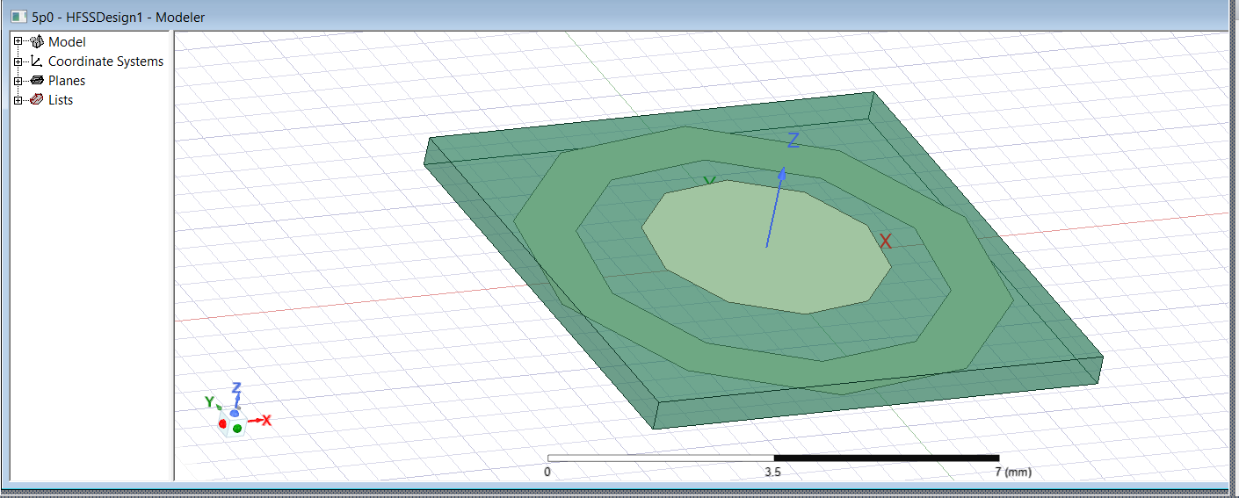



Substrate

Copper



Fig (6.1) Simulation Image of FSS in HFSS Software of Decagon Strip

**6.3 Methodology**

**6.3.1 FSS Design Overview and Parameter Specifications**

The FSS design targets specific transmission characteristics at selected frequencies using a periodic unit cell with three structural dimensions: gap size ([s]), strip width ([w]), and internal width ([w2]). Each parameter directly influences the resonance and transmission properties of the FSS.

The variable parameters, [s], [w], and [w2], are optimized to achieve target S21 values at key frequencies, with the following ranges:

* **Gap Size ([s])**: 4 mm to 8 mm
* **Strip Width ([w])**: 0.2 mm to 1 mm
* **Internal Width ([w2])**: 0.2 mm to 1 mm

The design goal is to meet specific S21 transmission coefficient criteria within selected frequency bands:

* **S21 < -15 dB** at 4.5 GHz and 6 GHz
* **S21 > -3 dB** at 8.5 GHz and 10 GHz

This objective requires the FSS to effectively filter or pass certain frequencies, which is crucial for applications needing controlled wave propagation.

**6.3.2 Forward Prediction Network (FPN)**

The Forward Prediction Network (FPN) is a fully connected neural network designed to predict the S21 transmission coefficient for the FSS, based on the structural parameters ([s], [w], [w2]). The FPN is trained using simulated S21 data across a frequency range, allowing it to approximate the relationship between FSS parameters and transmission characteristics. By replacing traditional simulations, the FPN significantly reduces computation time in the design process.

**FPN Architecture and Configuration**:

* **Input Layer**: The FPN accepts three inputs corresponding to [s], [w], and [w2].
* **Hidden Layers**: The network includes four dense layers with 64, 128, 256, and 128 neurons, respectively, with each layer followed by a LeakyReLU activation function and dropout regularization (0.2) to prevent overfitting and improve generalization.
* **Output Layer**: The output layer has 71 neurons, representing S21 values at 71 frequency points across the target range.

**Training Configuration**:

* **Loss Function**: Mean Squared Error (MSE) is used to evaluate model performance, capturing the average squared differences between predicted and actual S21 values.
* **Optimizer**: The Adam optimizer, with a learning rate of 1e-4, ensures efficient convergence.
* **Early Stopping and Learning Rate Scheduler**: EarlyStopping monitors validation loss to prevent overfitting, while ReduceLROnPlateau reduces the learning rate if validation loss stagnates.

**Data Preparation**: The FPN is trained on scaled data, with both input (parameters) and output (S21 values) standardized using StandardScaler. This preprocessing aids in faster convergence and more accurate predictions. The data is split with an 8:1:1 ratio for training, validation, and testing to ensure consistent model evaluation.

**6.3.3 Improved Particle Swarm Optimization (IPSO)**

The IPSO algorithm optimizes the FSS parameters ([s], [w], [w2]) based on predictions from the FPN. IPSO builds on standard PSO by incorporating adaptive inertia weights and dynamic learning factors, which enhance the algorithm’s convergence speed and accuracy.

**Key Components of IPSO**: Each particle in IPSO represents a potential configuration for [s], [w], and [w2]. The goal is to minimize the fitness function, indicating the best match to target S21 values at selected frequencies.

1. **Fitness Function**:
   * Fitness is calculated by comparing predicted S21 values (obtained from the FPN) to target S21 values. The fitness function, FFF, is Eq. 6.1:

$F= {\left(S_{21}^{9GHz}+15\right)}^{2}+{\left(S_{21}^{10GHz}+15\right)}^{2}+{\left(S_{21}^{12GHz}+15\right)}^{2}+{\left(S_{21}^{14GHz}+15\right)}^{2}$ (6.1)

1. where S21 represents the predicted transmission coefficient at frequency f. This fitness function penalizes deviations from the target, guiding the optimization toward configurations meeting the required transmission characteristics.
2. **Adaptive Inertia Weight (ω)**:
   * The inertia weight ω controls the balance between global and local search. A higher ω at the start encourages global exploration, while a lower ω later on refines the local search. Adaptive ω is Eq. 6.2:
$$ω_{i}^{d}=\left\{\begin{matrix}ω_{min}++\left(ω_{max}-ω_{min}\right)\frac{f(x_{i}^{d})-f_{min}^{d}}{f_{average}^{d}-f_{min}^{d}}, f(x_{i}^{d})≤f_{average}^{d} \\ ω_{max}, f(x_{i}^{d})>f_{average}^{d}\end{matrix}\right. (6.2)$$

3. **Dynamic Learning Coefficient (c2)**:
   * The social learning coefficient C2 reduces over time to prevent premature convergence. The formula for dynamic adjustment of C2 is Eq. 6.3:

$C_{2}= C_{2end}+\left(C_{2start}-C_{2end}\right)*e^{\left(\frac{w_{c}*t}{max⁡_iter}\right)}$ (6.3)

1. where C2start​ and C2end are the initial and final values, respectively, and wc controls the decay rate.
2. **Velocity and Position Update**:
   * Each particle’s velocity and position are updated using Eq. 6.4 and Eq. 6.5:

**Velocity Update**:

$V_{ij}\left(t+1\right)=ωV_{ij}\left(t\right)+C_{1}.{rand}_{1}.\left(p_{ij}-X_{ij}\right)+C_{2}.{rand}_{2}.(g_{j}-X_{ij})$ (6.4)

**Position Update**:

$X_{ij}\left(t+1\right)=X_{ij}\left(t\right)+V_{ij}(t+1$ (6.5)

This update guides particles towards the optimal configuration, refining the FSS parameters to meet the target S21 specifications.

1. **Convergence**:
   * The process continues until a stopping criterion is met, such as reaching a maximum number of iterations or a satisfactory fitness level. The best particle configuration at convergence represents the optimized parameters for the FSS design.

**6.4 Results and Analysis**

**FPN-IPSO Model Performance**

The FPN-IPSO model was evaluated based on S21 prediction accuracy and optimized FSS parameters.

* **S21 Prediction**: The FPN achieved low MSE and high R² scores, indicating strong accuracy in S21 predictions. A plot of predicted versus actual S21 values validates this performance.
* **Parameter Optimization**: IPSO optimized [s], [w], and [w2] to meet target S21 values at key frequencies (4.5 GHz, 6 GHz, 8.5 GHz, and 10 GHz).

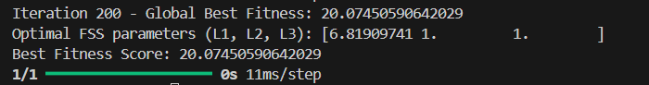

Fig (6.2) Output of the Model (Optimal Parameters)

**Visualization**: A comparison plot of predicted versus target S21 values and a heatmap of the optimized parameters at key frequencies demonstrate IPSO’s effectiveness in achieving the desired transmission profile.

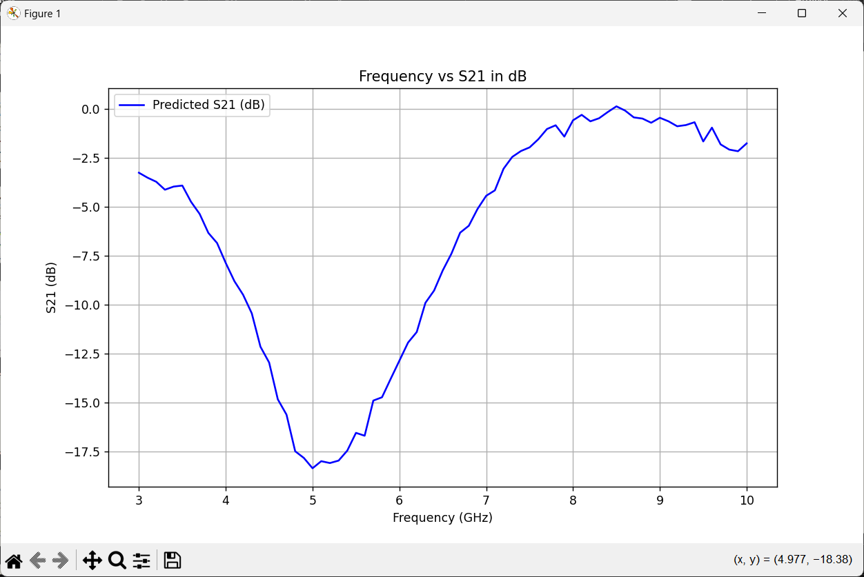

Fig (6.3) Visualization of Freq(GHz) vs S21 of Predicted Values (dB)

**6.5 Summary**

This FSS design approach, combining FPN and IPSO, achieves rapid and accurate FSS optimization by replacing full-wave simulations with predictive modeling. The combined model significantly reduces design time while maintaining high accuracy, proving effective for fast FSS design and potential applications in complex electromagnetic devices.

**CHAPTER 7**

**SUMMARY AND CONCLUSION**

In this thesis, AI Based Design For FSS. This chapter summarizes the overall work done, conclusions obtained and the directions for the future work.

**7.1 SUMMARY**

The three phases in the development of the AI-based design for Frequency Selective Surfaces (FSS) provide a comprehensive, efficient, and accurate approach to optimize FSS structures for specific RF and microwave applications.

1. **Phase 1: Introduction and Initial FSS Design**  
   The first phase introduced the concept of FSS and its importance in controlling electromagnetic wave propagation in various applications like antennas and radomes. Traditional methods for designing FSS require extensive full-wave simulations, which are computationally expensive. The AI-based approach combines machine learning (FPN) and optimization algorithms (PSO) to reduce simulation time while maintaining accuracy in predicting S21 transmission coefficients and optimizing structural parameters.
2. **Phase 2: Implementing the FSS Design with FPN and IPSO**  
   In this phase, the FPN was developed to predict the S21 transmission coefficient of FSS designs based on structural parameters such as inner side length (2L1), outer side length (2L2), and internal patch side length (2L3). The FPN used a neural network to approximate these relationships, replacing full-wave simulations. The IPSO algorithm was used to optimize the design parameters ([L1], [L2], [L3]) based on the FPN’s predictions, effectively achieving the desired transmission characteristics. This phase demonstrated the significant reduction in design time and computational effort, offering an efficient alternative to traditional FSS design methods.
3. **Phase 3: Refining the FSS Design with AI Optimization**  
   The third phase applied a similar AI-driven approach, but with a focus on optimizing parameters like gap size ([s]), strip width ([w]), and internal width ([w2]) for FSS designs targeting specific frequency bands (e.g., 4.5 GHz, 6 GHz for filtering and 8.5 GHz, 10 GHz for transmission). Again, the FPN was used to predict S21 values for the given parameter configurations, while IPSO optimized the design parameters to achieve the required S21 values at selected frequencies. The results confirmed that this combined FPN-IPSO approach was highly effective, yielding optimal design parameters while significantly reducing the design time compared to traditional methods.

**7.2 Conclusion**

The AI-based approach combining Forward Prediction Networks (FPN) and Improved Particle Swarm Optimization (IPSO) across the three phases provides a powerful, efficient, and accurate method for designing Frequency Selective Surfaces (FSS). By utilizing machine learning for fast S21 prediction and optimization algorithms for parameter tuning, the design process is dramatically accelerated—reducing the computational time by largely compared to conventional full-wave simulation methods.

The success of this methodology in predicting transmission characteristics and optimizing FSS parameters across different frequency ranges demonstrates its potential for broader applications in RF and microwave design. This AI-driven approach not only enhances the efficiency of FSS design but also opens avenues for its use in more complex electromagnetic devices and systems, where rapid and precise parameter optimization is critical.

**7.3 DIRECTION FOR FUTURE WORK**

1. **Validation with Real-World Data**: Future research could validate the FPN predictions by fabricating FSS prototypes and comparing them with measurements, refining the model further. Incorporating hybrid methods combining AI with full-wave simulations could also optimize computational efficiency without compromising accuracy.
2. **Advanced Optimization Techniques**: Exploring hybrid or multi-objective optimization algorithms could improve FSS designs by balancing various performance criteria, such as minimizing transmission loss while maximizing bandwidth.
3. **Material and Manufacturing Considerations**: Future studies can include material properties (e.g., dielectric constants, loss tangents) and manufacturing tolerances in the optimization process, making the designs more realistic and feasible for practical applications.
4. **Scalability and Real-Time Optimization**: Scaling the model for larger FSS arrays or integrating real-time optimization tools for adaptive systems could expand its practical applications in dynamic environments.

**REFERENCES**

1. **R. Cong, C. Zhang, N. Liu, K. Yang, X. Gao, and X. Sheng,** "A Novel Method for Frequency Selective Surface Design Using Deep Learning with Improved Particle Swarm Algorithm," *2022 IEEE the 9th International Symposium on Microwave, Antenna, Propagation and EMC Technologies for Wireless Communications (MAPE)*, 2022, pp. 374-379, doi: 10.1109/MAPE53743.2022.9935221.
2. **Z. Gu, D. Li, Y. Wu, Y. Fan, C. Yu, H. Chen, and E.-P. Li**, "A Solution to the Dilemma for FSS Inverse Design Using Generative Models," *IEEE Transactions on Antennas and Propagation*, vol. 71, no. 6, pp. 5100-5108, Jun. 2023, doi: 10.1109/TAP.2023.3266053.
3. **N. Calik, M. A. Belen, P. Mahouti, and S. Koziel**, "Accurate Modeling of Frequency Selective Surfaces Using Fully-Connected Regression Model With Automated Architecture Determination and Parameter Selection Based on Bayesian Optimization," *IEEE Access*, vol. 9, pp. 38396-38408, 2021, doi: 10.1109/ACCESS.2021.3063523.
4. **B. Dokmetas, S. S. Shinde and M. A. Belen,** "Artificial Intelligence Based Deep Learning Surrogate Model for Design Optimization of Microstrip Frequency Selective Surface," *2024 International Conference on Emerging Smart Computing and Informatics (ESCI)*, Pune, India, 2024, pp. 1-4, doi: 10.1109/ESCI59607.2024.10497238.
5. **Y. Xie, Y. Wang and Q. Wang**, "Design of Frequency Selective Surface using Residual Network," *2024 International Applied Computational Electromagnetics Society Symposium (ACES-China)*, Xi'an, China, 2024, pp. 1-3, doi: 10.1109/ACES-China62474.2024.10699652.
6. **Z. Gu, D. Li, Y. Fan, L. Zhang, Y. Liu and E. Li**, "Intelligent Design of Arbitrary Bandstop FSS Through Deep Learning and Genetic Algorithm," *2022 Asia-Pacific International Symposium on Electromagnetic Compatibility (APEMC)*, Beijing, China, 2022, pp. 649-651, doi: 10.1109/APEMC53576.2022.9888547.